Support your Marching Griffins at their competitive shows by ordering your
2014 Marching Griffins Show Shirts
Orders due to blue mailbox by 3 pm September 3rd
Orders delivered September 11 after band practice

Student’s Name__________________________________________________
Parent Email ______ ______________________________________________
Parent Phone ____________________________________________________
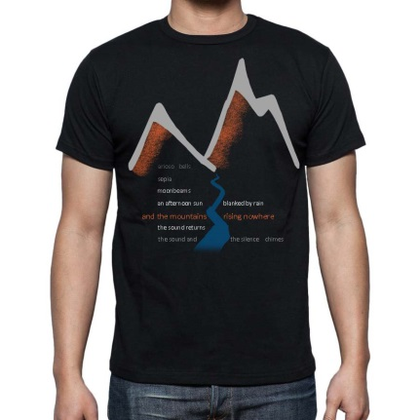
Front of shirt is pictured at left and is also pictured on www.lwemusic.org
Back of shirt will list 2014 Marching Griffins Itinerary.
Black, short sleeved t-shirts and hoodies available.
Accepted Payment: Checks payable to LWE Music Boosters or IBA transfers.
Questions? Contact Holly Williams :hollyscottwill@sbcglobal.net or
Shawn McCahey Shawnoc@sbcglobal.net

T-Shirt- $20 Qty Hoodie- $35 Qty
S ____ S ____
M ____ M ____
L ____ L ____
XL ____ XL ____
2XL(add $2) ____ 2XL(add $2) ____
3XL(add $3) ____ 3XL(add $3) ____
4XL(add $4) ____ 4XL(add $4) ____
5XL(add $5) ____ 5XL(add $5) ____

Total # Items Ordered __________
Total Amount Enclosed __________
IBA Transfer Request: Please transfer ___________from my student’s _________ IBA account
List dollar amount Student ID #
to pay for the cost of the competitive show shirt.

